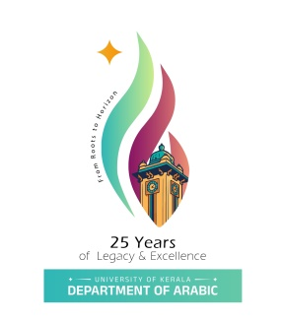 |  | 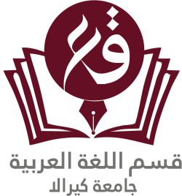

DEPARTMENT OF ARABIC
UNIVERSITY OF KERALA
Re-accredited by NAAC with ‘A++’ Grade

15th INTERNATIONAL CONFERENCE

ON

LANGUAGE AND SOCIAL DEVELOPMENT: THE GLOBAL RELEVANCE OF ARABIC
(15 - 17 December 2026)
KARIAVATTOM CAMPUS
UNIVERSITY OF KERALA, THIRUVANANTHAPURAM

Organizing Committee

Dr. Suhail E.  Organising Secretary  Head of the Department  Mob: 8826843244 | Dr. Thajudeen A.S.  Coordinator  Asst. Professor  Mob: 9446827141 | Dr. Noushad V.  Convenor  Asst. Professor  Mob: 9747318105

For more details visit: www.arabicku.in
arabiccampus@gmail.com
+91 9446827141
About the Conference
15th International Conference on
Language and Social Development: The Global Relevance of Arabic Language
Language is not merely a tool for communication; it is a vital catalyst for social development, cultural exchange, and economic integration. As globalization reshapes human interactions, the role of international languages in driving social progress and global connectivity has gained unprecedented significance. Among the major world languages, Arabic stands out as a powerful vehicle of heritage, modern diplomacy, and global development.
Being one of the official languages of the United Nations, Arabic connects over 400 million speakers across continents and serves as a bridge between diverse cultures and economies. In the contemporary world, the study and usage of Arabic extend far beyond traditional boundaries, playing a key role in corporate communication, international relations, translation studies, digital humanities, and cross-cultural dialogue.
The interplay between language and social development involves empowering communities, facilitating trade, enhancing educational pedagogy, and fostering global diplomacy. Understanding the global relevance of Arabic in this dynamic context requires interdisciplinary perspectives and academic discussions.
This international conference aims to bring together researchers, academicians, linguists, and experts from across the globe to explore the multifaceted dimensions of the Arabic language and its contribution to global social development, economic growth, and cultural synthesis..
Focal Areas / Sub-themes:
- India-Arab Diplomatic Relations: Past, Present, and Future
- Linguistic Evolution & Qur’anic Hermeneutics: The role of Qur’anic discourse and classical texts in shaping Arabic grammar, rhetoric, semiotics, and linguistic development.
- Hadith Literature & Ethno-Linguistic Studies: Linguistic dynamics, stylistic nuances, and humanistic/social values in Hadith literature and classical prose.
- Economic Development & Corporate Arabic: Arabic for Specific Purposes (ASP), diplomacy, international trade, tourism, and global employment opportunities.
- Pedagogy & Educational Empowerment: Modern methodologies in teaching Arabic, literacy initiatives, and social integration through language education.
- Digital Humanities & AI: Arabic NLP (Natural Language Processing), online Arabic content creation, and bridging the digital divide in the Arab world.
- Cultural Diplomacy & Social Identity: The role of Arabic in cross-cultural dialogues, diaspora studies, and social transformation.
- Translation as a Tool for Social Progress: Bridging knowledge gaps through translation of scientific, humanities, and literary works between Arabic and world languages.
- India and the Arab World: Historical, socio-economic, and literary ties connecting India and the Arab region.
NB: The participants outside the country should obtain Conference Visa from authorised Indian representative abroad. The conference will be held in accordance with the approvals of the Central Ministries of Home, External Affairs, Higher Education, and the Home Department of Govt. of Kerala.
The conference papers to be presented preferably in Standard Arabic.
Abstract of the paper should be send on or before 25th August 2026. Late Entries will not be entertained.
NB: Foreign Participants should invariably be advised to opt for 'conference visa' only (Website: https://indianvisaonline.gov.in/)
Important dates:
Abstract Submission Deadline : 25/08/2026
Notification of Accepted Abstracts : 10/09/2026
Full Paper Submission Deadline : 15/11/2026
Conference : 15/12/2026 to 17/12/2026
All Communications related to this conference are only to: arabiccampus@gmail.com

